Competitive Analysis Paper

ME360 Product Design

Avery Hellen, Waleed Khan, Jayden Ma, and Helena Gill

**Introduction**

In order to fully determine how successful our product will be in an open market, it is important to identify how successful currently existing solutions are, and then compare these solutions to our own. This competitive analysis will allow our team to modify the audience or the market segment we are addressing, or to provide evidence that our product addresses the solution better than our competitors.

Our product is an automated mask dispenser which relies on gravity and rollers to dispense one mask at a time upon request. Because the market segments we are selling to are commercial businesses and doctors’ offices, we have found two existing solutions which our product would compete against.

**Two Different Solutions**

**Approach 1: Manual Mask Dispenser**

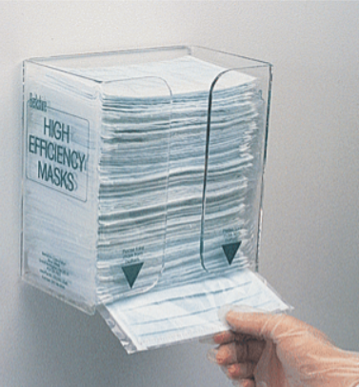

*(Source:* [*https://www.terrauniversal.com/face-mask-dispensers.html*](https://www.terrauniversal.com/face-mask-dispensers.html)*)*

**Approach 1: Strengths and Weaknesses**

One solution to the market is the gravity fed mask dispenser seen in the image above. The solution has the same goal of dispensing masks for individuals in a public setting. However, it is important to assess the strengths and weaknesses of this device as it is crucial to analyze its effectiveness in combating the coronavirus pandemic. A strength of this device is that it could be mounted almost anywhere as it is quite light. It won’t require a lot of labor, tools or equipment to try and keep this attached to a wall. In addition, the dispenser is quite cheap and reliable as it is composed of merely masks in an acrylic housing. There aren’t many costs associated with this design and will not require power. Similar to our design, this device can hold the same number of masks as our prototype.

With the strengths in mind, it is crucial to assess the weaknesses of the shown dispenser as well and what it means for the current pandemic. One weakness is that there is no limit on how many masks a person may take. It is important to be conservative with the masks that we have because of how contagious and widespread the coronavirus has become. Another issue with the shown dispenser is contamination. When someone takes a mask from the dispenser, there is a high percent chance of touching the other masks and spreading germs and potentially the coronavirus. Our prototype has taken these crucial weaknesses into considerations at the expense of a slight increase in cost. We feel it is important to construct a dispensing machine that ensures the safety and well-being of our fellow citizens in humanity.

**Engineering Perspective Analysis**

From a quantitative standpoint, this solution is easy to compare with an electronic mask dispenser because it serves an identical purpose: to deliver a mask. The feeding approach is the same for both solutions, since gravity provides the force to cycle the masks downwards and load a new mask for dispensing when one is taken. It is important to realize the limitations of how each device can be scaled, however. For both solutions, the limit for the amount of masks is restricted to the point in which the bottom mask could not slide out from underneath the stack. The limitation differs with each approach since the competition relies on the users strength and grip to pull the masks from the stack, whereas our solution relies on the coefficient of friction between the neoprene rollers and the plastic wrap around the masks. It is clear that the coefficient of friction is higher with the conventional approach as opposed to the more mechanical, electronic approach.

Another difference in the engineering approaches is the power required for the device to function properly. In the competitor’s solution, no power is required whereas our approach requires electricity to power the Arduino, motors, and sensors. We could quantify this power draw at around 2.0 Watts. Instantly, we see different limitations that the non-electronic dispenser is not held to. Since there is no power required, we can place the competitor's device anywhere that it can fit. Our solution requires power input, so it must be near an outlet at all timesor fitted with a rechargeable battery.

The main differences culminate into a major cost discrepancy in the manufacturing of each device. Our solution has a higher cost due to the electronic components and increased housing complexity to include the mechanism. This requires expensive molds (if this was to be injection molded for mass production) and expensive tools to assemble the components. With the conventional solution the only applicable manufacturing cost is for the material (acrylic) and machinery to cut and bend the material into the desired shape. The only other hardware would include mounting screws, but this is common between both solutions so it's not a major comparison.

**Approach 2: Delivery services**

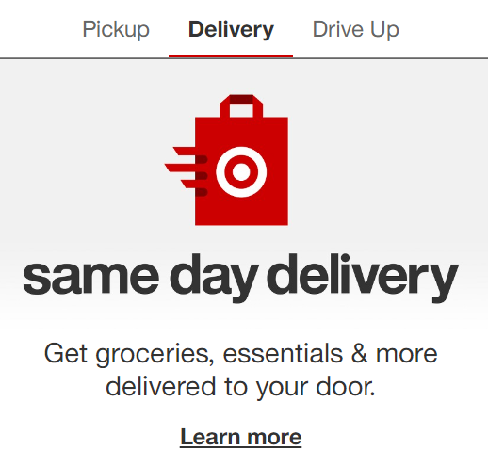

*(Source:* [*https://www.target.com/c/same-day-delivery/-/N-bswkz*](https://www.target.com/c/same-day-delivery/-/N-bswkz)*)*

**Strengths/Weaknesses**

For the second competitor, we considered market solutions that solves the need of wearing face masks, and therefore eliminating the need of a dispenser. One such solution considered is delivery services used by businesses to bring their products to the customer. This is more sterile as it does not require the customer to enter the store at all, and removes direct human-to-human interaction. This is also more convenient to the customer, who will not need to leave the comfort of their home at all or put on a mask. Because of this convenience, they would be more likely to use the service and it will therefore increase the overall demand for the business.

Another version of the second competitor are telehealth apps which allow for doctors to have appointments with patients without either entering into a doctor’s office. This allows for the reduction of person to person contact in a more high risk setting, and creates a more accessible experience for people with limited mobility.

A drawback of having delivery services, however, is the overhead cost associated with creating and maintaining a system for delivery. Compared to the initial costs of simply buying a mask dispenser and bulk ordering masks, delivery services require a dedicated hosted website, delivery drivers, and delivery vehicles which would cost significantly more money, especially if third-party services are utilized. The logistics involved with planning deliveries would also be considered, and likely would require additional labor costs.

A drawback of the telehealth app is similar to the drawback with the delivery services, where the additional cost of adding an app with the capabilities to provide the necessary service or contracting out to a third-party would be larger than the cost required to buy and maintain our automated dispenser. Additionally, this may not add more customers to justify the cost and it doesn’t completely address the need as telehealth apps are limited in nature. Doctors would only be able to address specific questions or perform visual diagnoses while the need for surgery, physical therapy, or other related services would still exist.

**Engineering Perspective Analysis**

With the creation of a delivery service, a company must add more facilities, workers, and inventory to meet the demand in a reasonable amount of time. For example, in order to reduce shipping time and cost, warehouses and processing centers will have to be located strategically between where the products were manufactured or sourced, and areas of large populations. Additionally, this would increase the amount of inventory necessary as the ordering websites can be locally focused, but are usually operated on a national or international scale. The delivery service requires engineering expertise in supply chain management and manufacturing, as well as website development and maintenance. When specifically referring to the telehealth app, this service only requires the website or app development and corresponding IT infrastructure to maintain it. However, the cost of IT infrastructure is significant, even when done with a third party, due to the constant need for it.

Because the automatic mask dispenser is a reusable product with some maintenance costs, such as the masks which are purchased separately, the automatic mask dispenser requires far less commitment, resources, and organization to resolve the problem of customers without masks.

Sources

“He said when Target fulfills an online order from the back of its stores versus shipping from a distribution center, “about 40% of the cost goes away.” He said when customers order online and pick up at a store, use curbside pickup or select shipping via Shipt, “about 90% of the cost goes away”

<https://www.cnbc.com/2019/11/20/target-is-cutting-costs-by-90percent-thanks-to-its-same-day-delivery-options.html>

“Walmart is projecting losses of more than $1 billion for its US e-commerce division this year,”

<https://www.vox.com/recode/2019/7/3/18716431/walmart-jet-marc-lore-modcloth-amazon-ecommerce-losses-online-sales>